WeChat Sandbox Registration Instructions

1. Login or Register in WeChat Application on you Smartphone.

 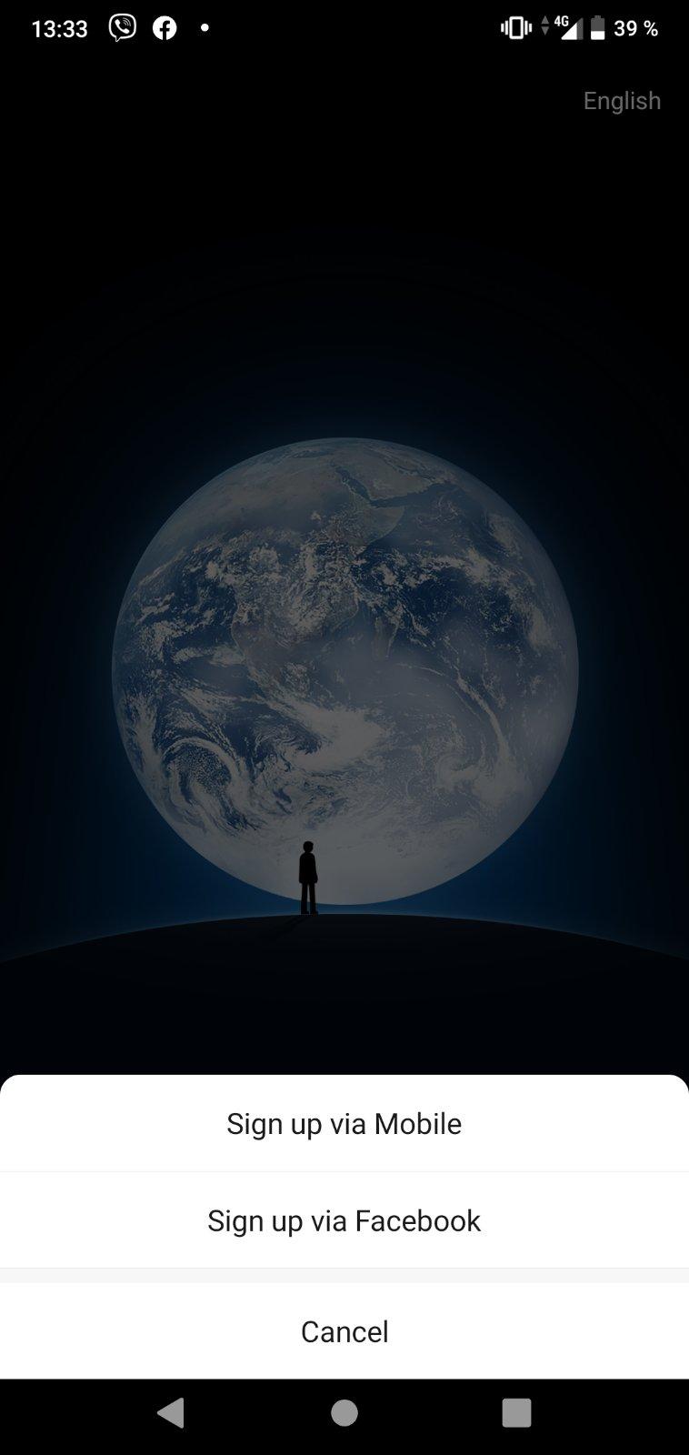

1. Open the Link <https://mp.weixin.qq.com/debug/cgi-bin/sandbox?t=sandbox/login> and login trough QR-code. Press Scan in WeChat application

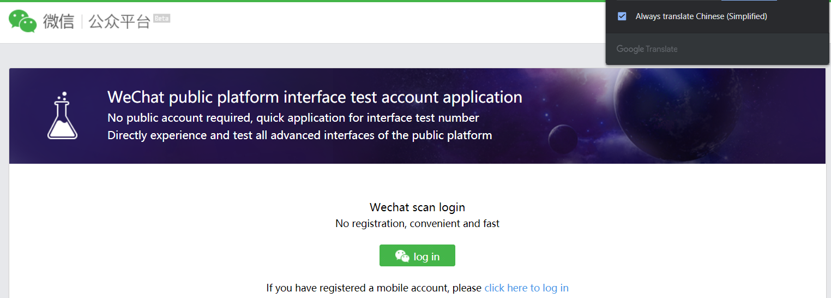

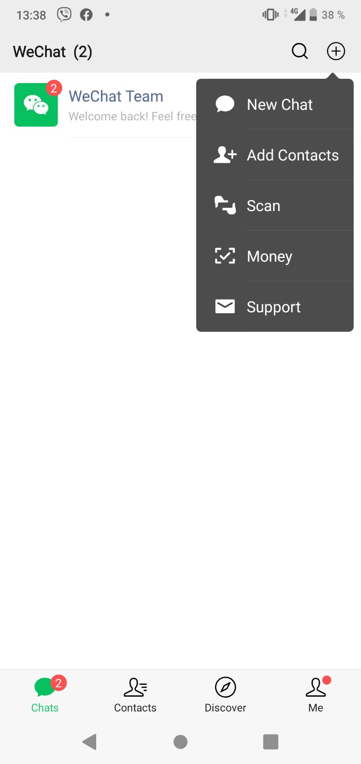

1. 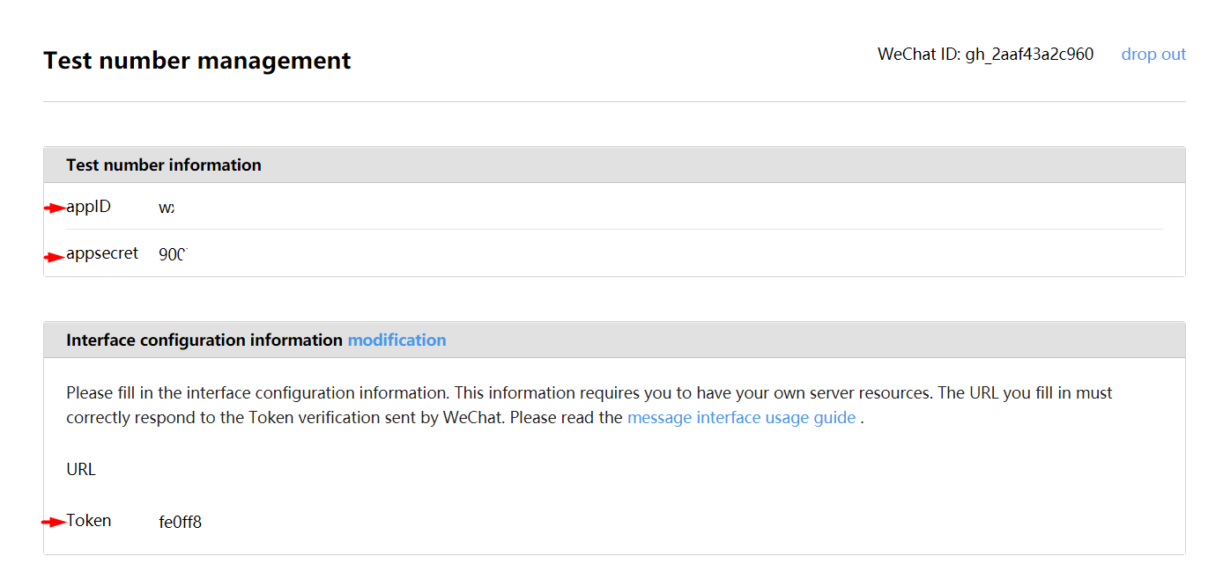After you were logged in sent to us the following info marked by red arrows.
2. We will input that credentials into our service and return Webhook URL, which you have to place into URL on the previous screenshot.
3. After URL will be placed you can scan the QR below and write to the chat from WeChat App on your Smartphone.
4. In addition, you need to provide information about the Endpoint(URL) and the Workgroup on the Genesys side.